Concept Guide: Introduction to Computers, Programming, and Java
Course: CS 200
Introduction to Java Programming, Comprehensive Version, 11th ed. Text
Chapter: 1 Introduction to Computers, Programs and Java

Concept/Topic: | Text Notes: | Lecture Notes:
hardware

Software

components of the system unit

CPU

Components of the CPU

Information Processing
Cycle

main memory

bit /byte / nibble

storage

software:
System Vs. Application

Operating System

input devices

output devices

Java Language Specifics

Applications Vs. Applets

Programming Languages:
High-level Vs.
Low-level

Procedural
Vs.
Object-Oriented Programming

Common Elements to All Programming Languages:
- keywords/reserved words
- operators
- punctuation
- identifiers
- syntax

Terminology: Programmer/Developer

Terminology:
User (types)

Terminology: API

Terminology: IDE |  | 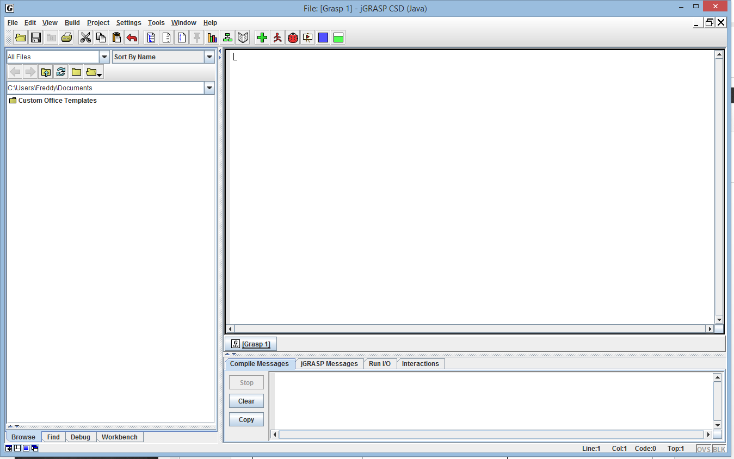
Terminology: method

Terminology: variable

Terminology: data type

Documentation:
Comments (examples)

Documentation:  Programming Style |  | 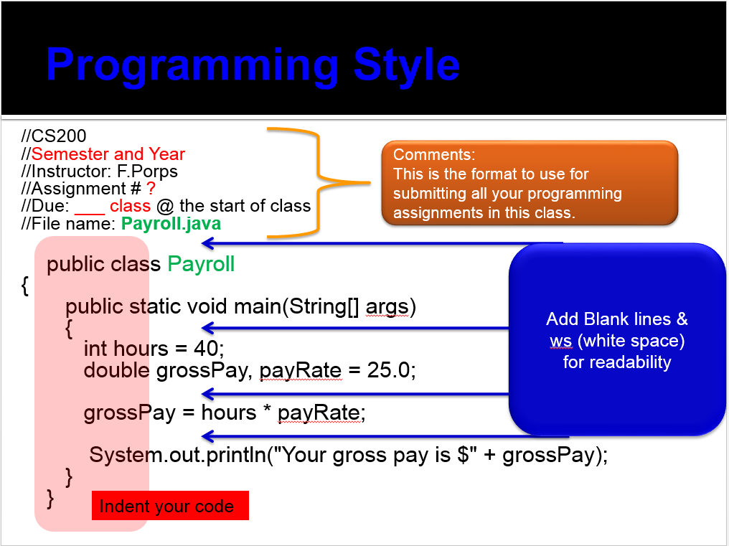
Programming Rule #1

Flowchart  (have a plan)  then  Code! |  | 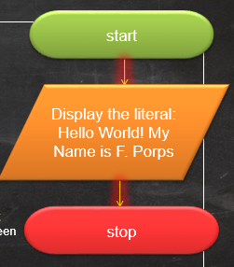
How do I start coding?
Use the Empty Java File Template.
(There is a link to it in the left nav bar on the CS 200 home page.)
Help with syntax errors

