Concept Guide: Overview of the Programming Process
Course: CS 200
Introduction to Java Programming, Comprehensive Version, 12th ed. Text
Chapter: 2 Elementary Programming (pages: 61-70)

Concept/Topic: | Text Notes: | Lecture Notes:
Algorithm

Software Development
Cycle
Overview

1. Design Phase

Flowcharting

Pseudo-code

2. Implementation Phase

3. Testing Phase

4. Debugging Phase

Types of Errors:
Compile
Run-Time
Logic

5. Documentation

OOP

Object Features

Class
Encapsulation
and
Information Hiding

Polymorphism

Inheritance |  | 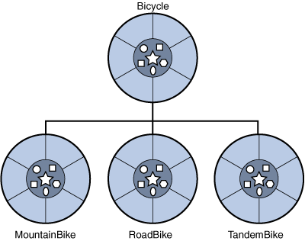
The Java API Heirarchy |  | Hierarchy For Package java.lang (limited display):  - class java.lang.Object  - class java.lang.Boolean  - class java.lang.Character  - class java.lang.Class  - class java.lang.Math  - class java.lang.Number  - class java.lang.Byte  - class java.lang.Double  - class java.lang.Float  - class java.lang.Integer  - class java.lang.Long  - class java.lang.Short  - class java.lang.String  - class java.lang.System
What library is imported into every program by default?
The Scanner Class

Lab Activity |  | Modify the “Hello World” program:  - add a prompt for your age as an integer value  - a prompt is a screen output message requesting data  - it should be specific as to the data you require  - store the input value for use  - remember: make storage space for the data you are going to get, before you ask for the data  - echo your age back to the screen after your name.  - Rename class: HelloWorld2.java and save file as HelloWorld2.java
Error:
Undeclared
Uninitialized
Variables
And
Unused
Variables
Error:
Integer
Overflow

Error:
Round-off
Error

Error:
Unintended
Integer
Division
THIS IS A BIG ONE – WATCH FOR IT!
Warning:
Redundant
Input
Objects

