Concept Guide: Basic Computation: The Main Method, Expressions and Data Storage (Variables\Constant\Literals) Course: CS 200
Introduction to Java Programming, Comprehensive Version, 12th ed. Text
Chapter: 2 Elementary Programming (pages: start of chapter to page 61)

Concept/Topic: | Text Notes: | Lecture Notes:
Programming Style |  | (use payroll.java handout)
Comments |  | (use payroll.java handout)
Case-Sensitive

Access Specifiers

Identifier

Class Rules with Files

Method Definition

Method Header

Method Body

Java Punctuation

Keywords/Reserved Words |  | (see additional handout)
Keywords and Identifiers – What’s the difference?

Rules for Naming Identifiers

Conventions for Naming Identifiers

Literal

Variable

Constant

API

System Class

print & println

Escape Sequences

File Extensions

Lab Time! |  | Flowchart then code & run!  Problem: Create a program to display the following text as illustrated, using only 3 lines, replacing the descriptions with your own data:  today’s date  your name, your partner’s name  your favorite food/least favorite food, your partner’s favorite food/least favorite food  Using exactly:  1 string concatenator,  2 print commands, and  2 println commands.  Working with a partner…
Primitive Data Types |  | (see additional handout)
The char Data Type

Two’s Complement Method (for storing negative integer values)

Variables: Declarations &
Initializations

Forcing Data Types

Variable Ranking |  | 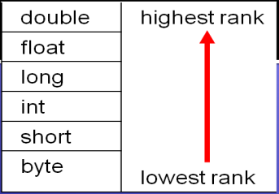
Type Casting

Operators:  Assignment  Arithmetic  Augmented/  combined assignment  increment (++)  decrement(--)  prefix position:  postfix position: |  | (see additional handout)
Operator Precedence

The Math Class

Scope

Lab Time! |  | Modify the payroll program to get the number of hours worked and the pay rate from user input.

