Concept Guide: Details: String Object, Math Class, and other I/O housekeeping
Course: CS 200
Introduction to Java Programming, Comprehensive Version, 11th ed. Text
Chapter: 4 Mathematical Functions, Characters, and Strings
Concept/Topic: | Text Notes: | Lecture Notes:
Declaring String Object

String Values |  | http://www.unicode.org/charts/  (Print it)
The Empty String

The Entire String Class |  | http://docs.oracle.com/javase/7/docs/api/java/lang/String.html  (Print it)  List of ones to know:
How are Strings Stored? |  | 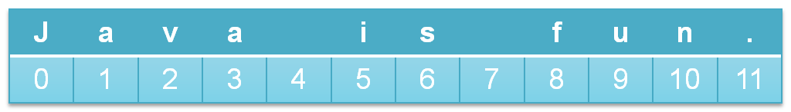
the dot operator (.)

String Method:
charAt(x);

String Method:
length();

String Method:
indexOf(x);

String Method:  comparing string objects |  | 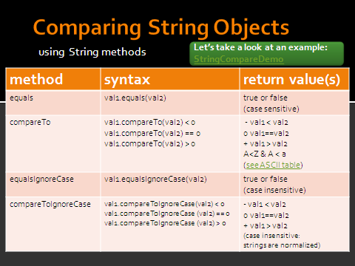  Methods have a return type…  ex. main has a return type of void  (no value is returned)  The methods of the String Object  return boolean & int values
Concatenating Strings

Working with substrings

String Bounds

The Escape Sequences |  | 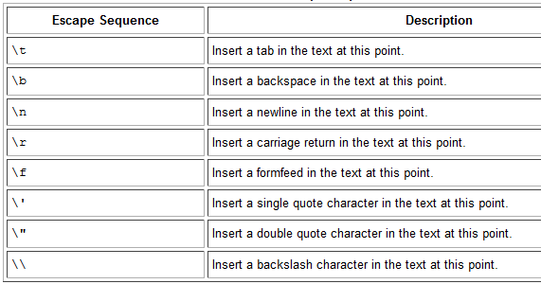
Methods of the Character  Class | 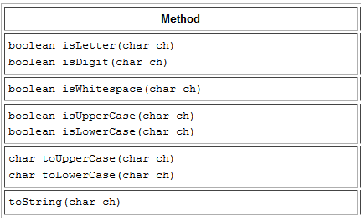 | 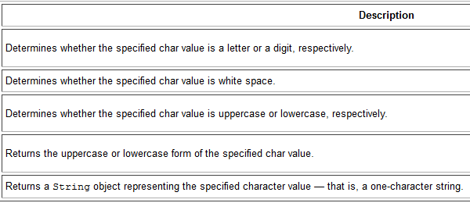
Casting between  char and Numeric  Types |  | See text page 127
Conversion between  Strings and  Numbers |  | parseInt  parseFloat  parseDouble  “” //concatenate empty string  See text page 137
Math API:  methods to know –  - pow  - sqrt  - ceil  - floor  - round  - max  - min  - abs  - random |  | http://docs.oracle.com/javase/1.5.0/docs/api/

