SOME SAMPLE QUESTIONS
Note: The purpose of this document is to give you an idea of the questions on the quiz.
Assembly Programming Introduction
1. Assume the following values are stored at the indicated memory addresses and registers:
Address Value Register Value
0x100 0xFF %rax 0x100
0x104 0xAB %rcx 0x1
0x108 0x13 %rdx 0x3
0x10C 0x11
Fill in the following table showing the values for the indicated operands:
Operand Value Answer Comment
%rax __________ 0x100 Register
0x104 __________ 0x AB Absolute address
$0x108 __________ 0x108 Immediate
(%rax) __________ 0xFF Address 0x100
4(%rax) __________ 0xAB Address 0x104
9(%rax,%rdx) __________ 0x11 Address 0x10C
260(%rcx,%rdx) __________ 0x13 Address 0x108
0xFC( ,%rcx,4) __________ 0xFF Address 0x100
(%rax,%rdx,4) __________ 0x11 Address 0x10C

Command Suffix (Optional feature):
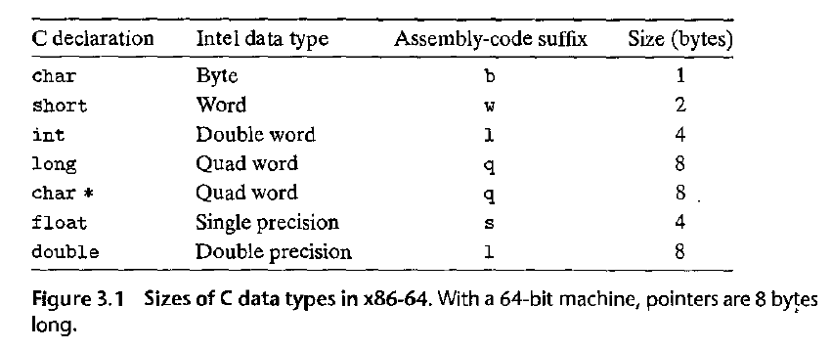
Example MOV instruction:
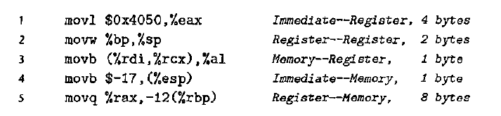
2. For each of the following lines of assembly language, determine the appropriate instruction suffix based on the operands. (For example, mov can be rewritten as movb, movw, movl, or movq.)
mov_ %eax, (%rsp) l
mov_ (%rax), %dx w
mov_ $0xFF, %bl b
mov_ (%rsp,%rdx,4), %dl b
mov_ (%rdx), %rax q
mov_ %dx, (%rax) w

3. Each of the following lines of code generates an error message when we invoke the assembler. Explain what is wrong with each line. (Assume 64 bit machine)
movb $0xF, (%ebx) Cannot use %ebx as address register (addresses are 8 bytes long)
movl %rax, (%rsp) Mismatch between instruction suffix and register ID
movw (%rax),4(%rsp) Cannot have both source and destination be memory references
movb %al, %sl No register named %sl
movq %rax, $0x123 Cannot have immediate as destination
movl %eax, %rdx Destination operand incorrect size
movb %si, 8(%rbp) Mismatch between instruction suffix and register ID

4. LEA Command Examples:
Suppose register %rax holds value x and %rcx holds value y. Fill in the table below with formulas indicating the value that will be stored in register %rdx for each of the given assembly-code instructions:
leaq 6 (%rax) , %rdx 6+x
leaq (%rax, %rcx) , %rdx x + y
leaq (%rax, %rcx,4), %rdx x +4y
leaq 7 (%rax, %rax, 8) , %rdx 7 + 9x
leaq 0xA(,%rcx,4), %rdx 10 + 4y
leaq 9(%rax,%rcx,2), %rdx 9 + x + 2y
5. Find the C expression t:
long scale(long x, long y, long z) {
long t = ______________________
return;
When
long scale(long x, long y, long z)
x in %rdi, y in %rsi, z in %rdx
scale:
leaq (%rdi,%rsi,4), %rax x + 4*y
leaq (%rdx,%rdx,2), %rdx z + 2*z = 3*z
leaq (%rax,%rdx,4), %rdx (x+4*y) + 4*(3*z) = x + 4*Y + 12*Z
ret

********************

